**TECH LASKIN**

**S. NURIL HIJAS(IT) , H. RUMA JAISWAL(IT) , J. VIDHYA (IT), R. VIVITHA(ECE)**

**Rajalakshmi Institute of Technology, Chennai**

**Rajalakshmi Engineering College, Thandalam**

**ABSTRACT:**

Embedded system has been drastically developed from the last decade which made its application much more important in many fields. The main theme of our project is to provide a touchscreen calculator. The touchscreen calculator has the primary mathematical operations such as addition, subtraction, multiplication and division. This project was implemented by using ULK (Unified Learning Kit). The GLCD screen will display the numbers and operations that looks alike calculator. The user’s input will be displayed in the CLCD screen as well as in the console window. This may ease and comfort the user.

**INTRODUCTION:**

UTLP (Unified Technology Learning Platform) is an ardent facilitator which uses a kit named ULK (Unified Learning Kit) for aiding engineers gain hands on, learn and understand complex problems and advance technologies simply. Besides, UTLP also concentrates on making students ready as it gives them the experience of working in real time. UTLP also embraces modern technologies to bridge the gap between academia and industry.

**BLOCK DIAGRAM:**

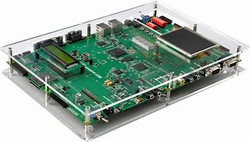 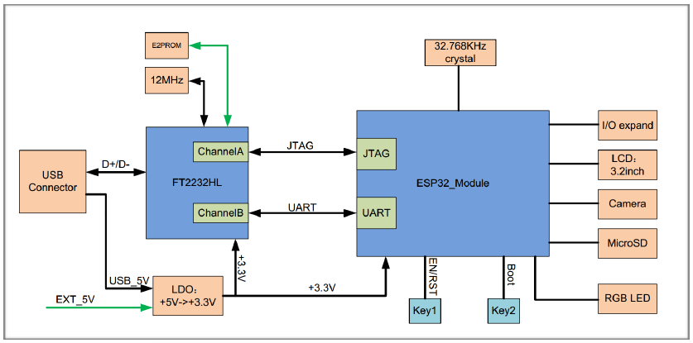

**HARDWARE DESCRIPTION:**

UTLP (Unified Technology Learning Platform) is an ardent facilitator which uses a kit named ULK (Unified Learning Kit) for aiding engineers gain hands-on, learn and understand complex and advance technologies simply. ULK is based on Texas Instruments OMAP3530 application processor which is a high performance processor based on ARM architecture. The ULK kit runs only on the UBUNTU PC of version 12. The Embedded C code is generated using Eclipse software. The CLCD and GLCD is also embedded on the kit which are used for the implementation. It is placed in the arm processor part and hence can be directly accessed while coding using Embedded C. Different APIs were used for enabling and disabling the touch feature on GLCD.The24 bit RGB and LCD control signals from OMAP 3530 processor has to be taken out to interface with GLCD

**FUTURE ENHANCEMENT:**

The future we can reconstruct our project and we can develop the project mainly for business operations. In future is not in a way of button, switches, and almost we are all use only the touch to display the process, so we are develop for the future problems.

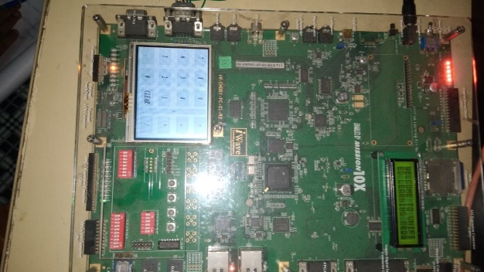

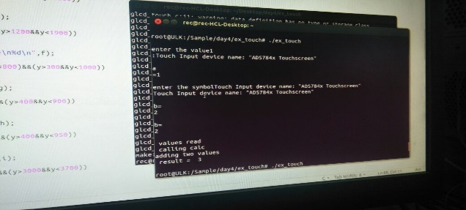

**PROPOSED SYSTEM:**

The touchscreen calculator is an embedded system, in addition to calculation it also handles operations like input from the GLCD screen and displaying the output in CLCD screen. When the user touches the numbers present in GLCD screen to perform calculations the result will be displayed on the CLCD screen. The touch feature makes the user to feel comfortable while performing the operation.

**CONCLUSION:**

Thus the calculator which performs simple calculations such as Addition, Subtraction, Multiplication, Division is developed using ULK kit. The problems encountered was converting the .jpg image to .bmp file and getting the input from user which has been solved and executed